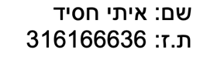 מטלה 9 – פוינטרים  
  
שאלה 1

#define SIZE 10

#include <stdio.h>

**int** main()

{

**int** arr[SIZE];

**int** *addressMin = arr, *addressMax = arr;

**int** temp;

printf("Please insert %d numbers: \n", SIZE);

**for** (**int** *p = arr; p < arr + SIZE; p++)

{

scanf("%d", p);

}

**for** (**int** *p = arr+1; p < arr + SIZE; p++)

{

**if**(*p < *addressMin)

{

addressMin = p;

}

**else**

{

**if** (*p > *addressMax)

{

addressMax = p;

}

}

}

printf("The address of the minimum number is %p\n", addressMin);

printf("The value of the minimum numbers is %d\n", *addressMin);

temp = *addressMin;

*addressMin = *addressMax;

*addressMax = temp;

printf("The new array is:\n");

**for** (**int** *p = arr; p < arr + SIZE; p++)

{

printf("%d ", *p);

}

printf("\n");

}

שאלה 2

#define SIZE 10

#include <stdio.h>

int main()

{

int phone_num[SIZE] = {0, 5, 4, 2, 8, 8, 7, 1 ,3 ,3};

int *p_phone_num[SIZE];

int i = 0;

for (int *ptr1 = p_phone_num; ptr1 < p_phone_num + SIZE; ptr1++)

{

*ptr1 = phone_num + i;

i++;

}

printf("My Phone number is: \n");

for (int *ptr2 = phone_num; ptr2 < phone_num + SIZE; ptr2++)

{

printf("%d", *ptr2);

}

printf("\n");

for (int *ptr3 = p_phone_num; ptr3 < p_phone_num + SIZE; ptr3++)

{

printf("%p\n", *ptr3);

}

printf("\n");

for (int *ptr4 = p_phone_num; ptr4 < p_phone_num + SIZE; ptr4++)

{

int *ptr5 = *ptr4;

printf("%d", *ptr5);

}

}

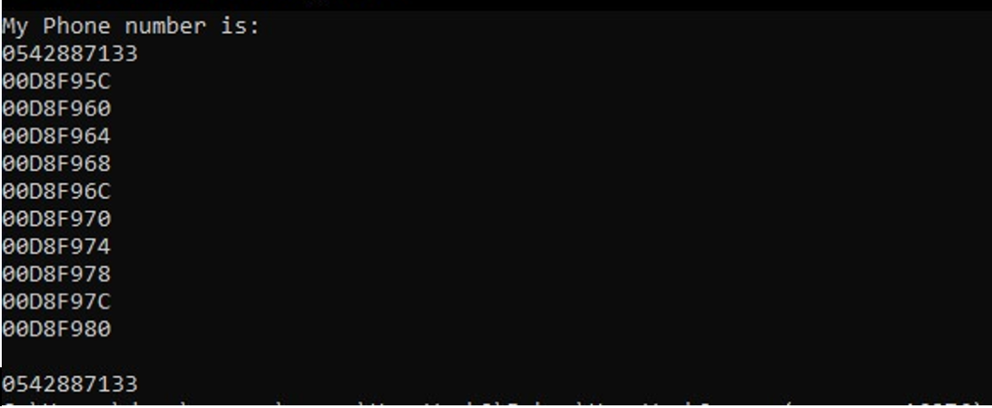

שאלה 3

#include <stdio.h>

#include <string.h>

#define SIZE 30

**void** removeSpaces(**char** *str1);

**int** main()

{

**char** str[SIZE];

printf("Please insert a sentence up to %d letters: ", SIZE - 1);

gets(str);

removeSpaces(str);

puts(str);

}

**void** removeSpaces(**char** *str1)

{

**char** *p1 = str1;

**char** *p2;

**while** (*p1 != '\0')

{

**if**(*p1 == ' ')

{

p2 = p1;

**while** (*p2 != '\0')

{

*p2 = *(p2 + 1);

p2++;

}

}

p1++;

}

}

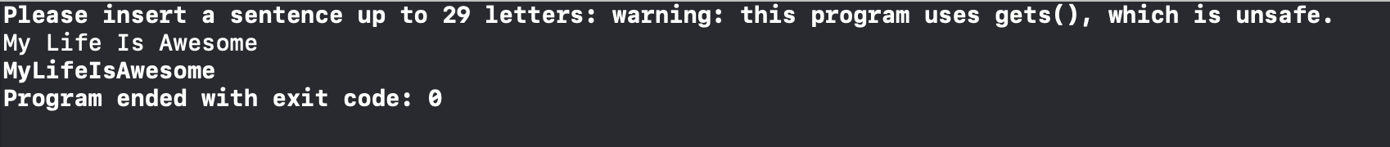

שאלה 4

#define SIZE 10

#include <stdio.h>

**void** mirror(**int** *arr, **int** size);

**int** main()

{

**int** arr[SIZE];

printf("Please insert %d numbers:\n", SIZE);

**for** (**int** *p = arr ; p < arr + SIZE ; p++)

{

scanf("%d", p);

}

mirror(arr, SIZE);

**for** (**int** *p = arr; p < arr + SIZE; p++)

{

printf("%d ", *p);

}

printf("\n");

}

**void** mirror(**int** *arr, **int** size)

{

**int** *s = arr;

**int** temp;

**for** (**int** *p = arr + size - 1; p >= arr + size/2; p--)

{

temp = *p;

*p = *s;

*s = temp;

s++;

}

}

